Florida safety culture support

Ascension Data Reconciliation
Identifying and correcting issues in Ascension’s 2024 AHCA hospital safety culture submission
Prepared by: Beterra Health
Date: June 2026
For: Ascension Florida Leadership

Section 1

Executive summary
Problem
…

Solution
…

Results
…

Next Steps
…

Key takeaway
Ascension’s reverse-worded questions were incorrectly coded in the 2024 AHCA submission across all eight facilities and can be corrected for resubmission. The correction improves the results of all eight hospitals.

Section 2

Background and scope
In September 2024, Ascension administered the AHRQ Hospital Survey on Patient Safety Culture (HSOPS) across eight hospitals and submitted the results to the Florida Agency for Health Care Administration (AHCA). The hospitals include: Pensacola, Gulf, Emerald Coast, and Bay, St. Vincent’s Southside (St. Luke’s), Riverside (St. Vincent’s Medical Center), Clay County, and St. John’s County.

During the Florida Safe Culture platform roll out, Beterra identified unusual data patterns that pointed to source data errors for Ascension. The hypothesis is negatively-worded (“reverse-worded”) questions had their responses inverted at the response level before scoring. Inverting the responses to negatively-worded questions distorted 8/10 composite measures across all eight hospitals depressing the results.

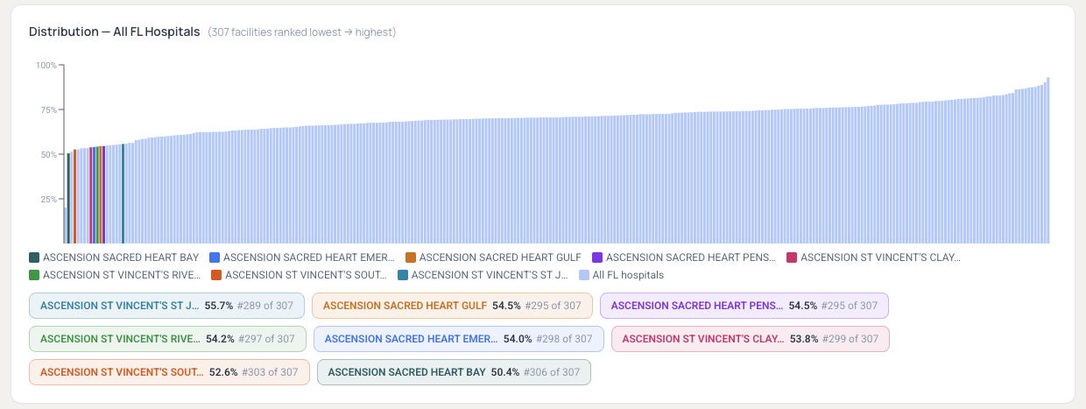
Figure 1: Florida Hospital Compare – distribution with Ascension facilities showing the low scoring across all eight
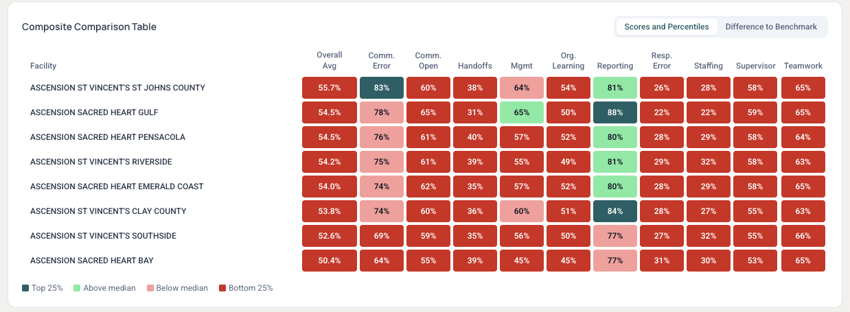
Figure 2: Florida Hospital Compare – Composite Comparison Table showing the composite-score comparison across all eight hospitals
While Ascension surveyed across multiple types of facilities and survey instruments, this review is scoped to the eight hospitals and the AHRQ Hospital Survey on Patient Safety Culture (HSOPS), which is the level at which data is submitted to AHCA. Other care settings are out of scope. It documents, from the ground up, how the data moved from collection to submission, which questions are affected and why, and the difference between the figures as originally submitted and the corrected results.
Highlight
Hypothesis: Were reverse-worded questions scored incorrectly at the point of the AHCA data submission for Ascension across facilities?

Section 3

Scoring the Survey
The AHRQ HSOPS survey includes thirty Likert questions in scope (the two Reporting Patient Safety Events items use a separate frequency scale, for thirty-two scored questions in total), and each question uses a five-point Likert scale (1 = strongly disagree to 5 = strongly agree). AHCA reports each result as a “percent positive response” (PPR): the number of positive responses divided by all responses, with neutral ("3") responses counted in the denominator.

The definition is the same for every question, but which responses count as positive depends on how the question is worded. Of the thirty Likert questions, seventeen are positively worded (e.g., "We work together as an effective team"), where "agree" (4) or "strongly agree" (5) is counted towards the PPR calculation. Thirteen are negatively worded (e.g., "Staff feel like their mistakes are held against them"), where agreement is unfavorable, so "disagree" (2) or "strongly disagree" (1) is counted towards the PPR.

Composites and where the reverse-worded questions sit
The Likert questions roll up into ten categories or “composites”. The table shows how many questions each contain and how many are reverse-worded. This determines whether the hypothesized error can affect that composite. The composites show 8/10 are affected by reverse-worded coding.

Composite | Total Questions | Positive-worded | Reverse-worded | Affected?
Teamwork | 3 | 2 | 1 | Yes
Staffing and Work Pace | 4 | 1 | 3 | Yes
Organizational Learning – Continuous Improvement | 3 | 2 | 1 | Yes
Response to Error | 4 | 1 | 3 | Yes
Supervisor / Manager Support | 3 | 2 | 1 | Yes
Communication Openness | 4 | 3 | 1 | Yes
Communication About Error | 3 | 3 | 0 | No; unaffected
Hospital Management Support | 3 | 2 | 1 | Yes
Handoffs and Information Exchange | 3 | 1 | 2 | Yes
Reporting Patient Safety Events | 2 | 2 | 0 | No; unaffected
Table 1: Reverse-worded question counts by Composite within the HSOPS tool

The thirteen reverse-worded questions
Item | Composite | Question wording
A3 | Staffing and Work Pace | Staff in this unit work longer hours than is best for patient care.
A5 | Staffing and Work Pace | This unit relies too much on temporary, float, or PRN staff.
A6 | Response to Error | In this unit, staff feel like their mistakes are held against them.
A7 | Response to Error | When an event is reported in this unit, it feels like the person is being written up, not the problem.
A9 | Teamwork | There is a problem with disrespectful behavior by those working in this unit.
A11 | Staffing and Work Pace | The work pace in this unit is so rushed that it negatively affects patient safety.
A13 | Response to Error | In this unit, there is a lack of support for staff involved in patient safety errors.
A14 | Organizational Learning – Continuous Improvement | This unit lets the same patient safety problems keep happening.
B2 | Supervisor / Manager Support | My supervisor, manager, or clinical leader wants us to work faster during busy times, even if it means taking shortcuts.
C7 | Communication Openness | In this unit, staff are afraid to ask questions when something does not seem right.
F3 | Hospital Management Support | Hospital management seems interested in patient safety only after an adverse event happens.
F4 | Handoffs and Information Exchange | When transferring patients from one unit to another, important information is often left out.
F5 | Handoffs and Information Exchange | During shift changes, important patient care information is often left out.
Table 2: Reverse-worded questions and AHRQ codes within the HSOPS tool
HIGHLIGHT
Within the HSOPS tool, 13/30 questions are reverse-worded and 8/10 composites contain reverse-worded questions

Section 4

Mapping the Data
The survey data passed through four points:
- Prior vendor survey and reporting: the vendor collected the responses and provided reporting materials to Ascension.
- Prior vendor data export: the vendor provided a web portal for Ascension to download the “raw data file” of survey results
- AHCA data-entry tool: Ascension proceeded to load the raw results into internal tooling (ex: Tableau) and AHCA’s macro-enabled Excel tool. This tool applies standard reverse-scoring and expects un-normalized responses.
- Submission: the tool produced the per-facility files for AHCA’s system submissions with the reverse-worded items still normalized.

The table traces a control question (“A1”, positively-worded) and a reverse-worded question (A3) through these points for the example of Sacred Heart Emerald Coast Hospital. The reverse-worded value is shown as correct in the prior vendor reporting but incorrect when calculated beyond that point. The control question is stable everywhere. This means that the prior vendor accounted for reverse-worded questions in their reporting but “normalized” the reverse-worded values in the Ascension provided data export.

Step | Example for Sacred Heart Emerald Coast  N = 419 submitted | A1 control (% positive)  “In this unit, we work together as an effective team.” | A3 reverse-worded (% positive)  “Staff in this unit work longer hours than is best for patient care.”
1 | Prior Vendor survey reporting | 94.4% | 53.4%
2 | Prior Vendor data export (“raw file”) | 94.4% | 18.1%
3 | AHCA macro-enabled Excel tool | 94.4% | 18.1%
4 | Submission to AHCA PSCS | 94.4% | 18.1%
Table 3: Data Chain of Custody – shows the difference in result scoring across the chain for questions A1 and A3 for Emerald Coast
The prior vendor’s own facility reports corroborate this. For Sacred Heart Emerald Coast the vendor report shows the question “In this unit, we work together as an effective team.” at 94.4% and the question “Staff work longer hours than is best for patient care” (A3) at 53.4%. This matches the corrected figures, not the submitted ones.

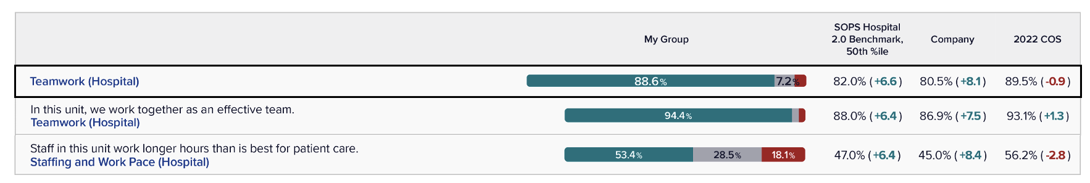

Figure 3: Prior vendor reports correctly displayed A1 and A3 results for Emerald Coast in “26016 EC Hospital Report COS 2024 Slide Deck.pptx” slide 5
highlight
For question A1 (positive-worded), the data is unaffected through the data chain of custody at Emerald Coast. For question A3 (reverse-worded), the data differs along the chain due to the prior vendor normalization of the raw data

Section 5

Confirming the Defect
Carrying the Sacred Heart Emerald Coast example through, the example fans out to the full data set for the hospital when viewing the percent positive, percent neutral, and percent negative for each composite before and after the reverse-worded questions are re-coded.

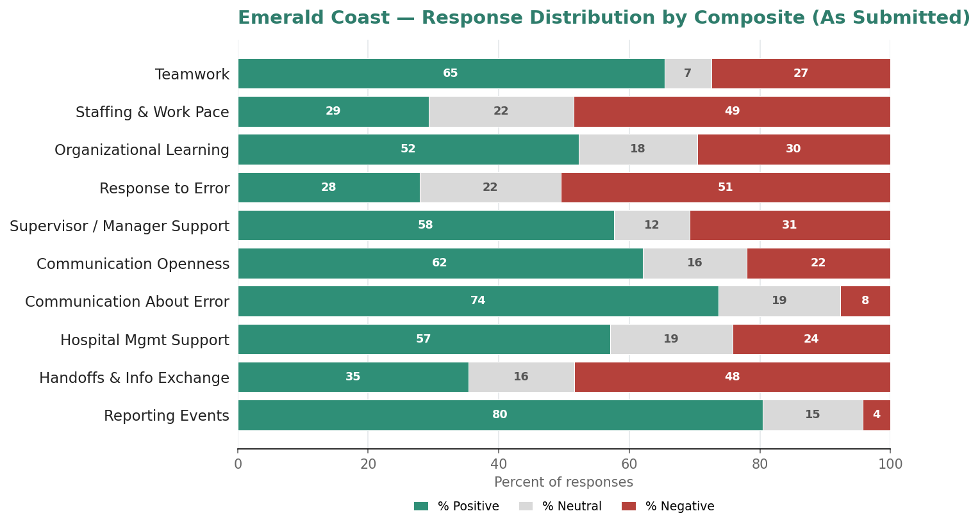
Figure 4: Emerald Coast – Response Distribution by Composite (As Submitted) shows large distribution of percent negative responses

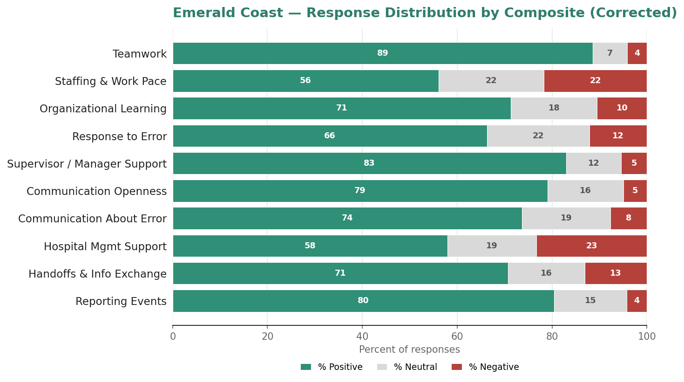
Figure 5: Emerald Coast – Response Distribution by Composite (Corrected) shows smaller distribution of percent negative responses

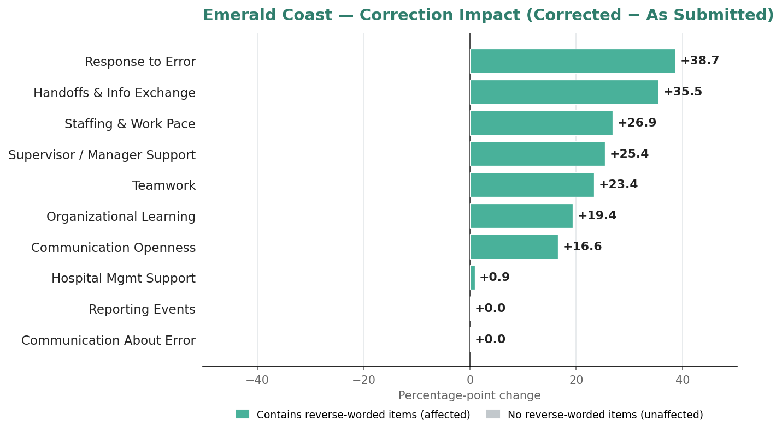
Figure 6: Emerald Coast – Correction Impact (Corrected – As Submitted) shows the shift in percent positive responses as a result of the correction

The full data set by facility, question, and composite can be found in the supplementary “chain_of_custody.csv”, and the issue persisted across all questions in all eight facilities. This proves the hypothesis that the reverse-worded questions were submitted incorrectly, and the issues are isolated to this problem as shown in Figure 6. The process map below shows exactly how the data moved along the chain of custody.
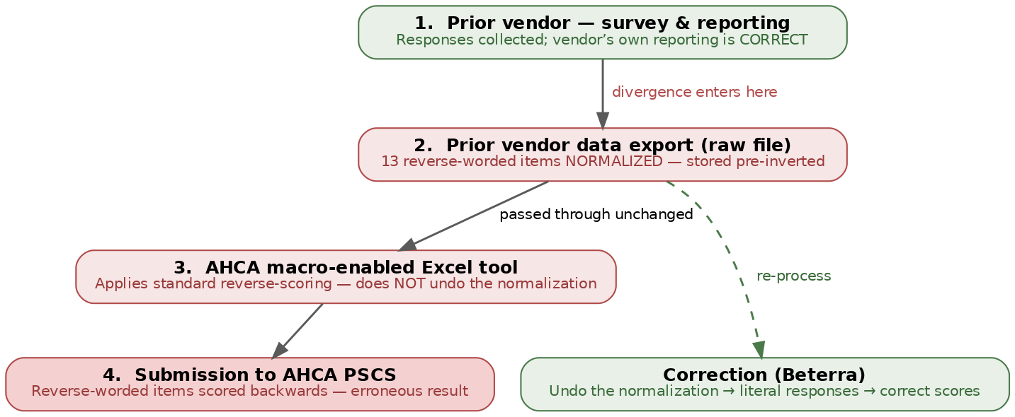
Figure 7. The Data Chain of Custody - The error originates in the prior vendor export where reverse-worded items were “normalized” and submitted to AHCA incorrectly. It is unknown whether communication around normalization of the data was provided to Ascension
highlight
Hypothesis is proven that reverse-worded question coding caused the data to be submitted to AHCA incorrectly. This was due to the prior vendor “normalization” of the reverse-worded questions at the point of data export to Ascension. This will be corrected.

Section 6

Reporting the Results
The table below shows each hospital’s overall percent positive as submitted versus corrected. All figures are the official scored values from the source data.

Hospital | Corrected  (OPPR) | As submitted  (OPPR) | Change  (OPPR)
Sacred Heart Pensacola | 70.5% | 54.4% | +16.1
Sacred Heart Gulf | 82.7% | 54.8% | +27.9
Sacred Heart Emerald Coast | 72.7% | 54.0% | +18.7
Sacred Heart Bay | 58.8% | 50.4% | +8.4
St Vincent’s Southside (St Luke) | 67.4% | 52.4% | +15.0
St Vincent’s Riverside (St Vincent Medical Center) | 67.6% | 54.3% | +13.3
St Vincent’s Clay County | 70.4% | 53.9% | +16.5
St Vincent’s St John’s County | 75.8% | 55.6% | +20.2
Table 4. Overall percent positive (OPPR) by hospital — source-data (as-submitted) scores versus corrected.
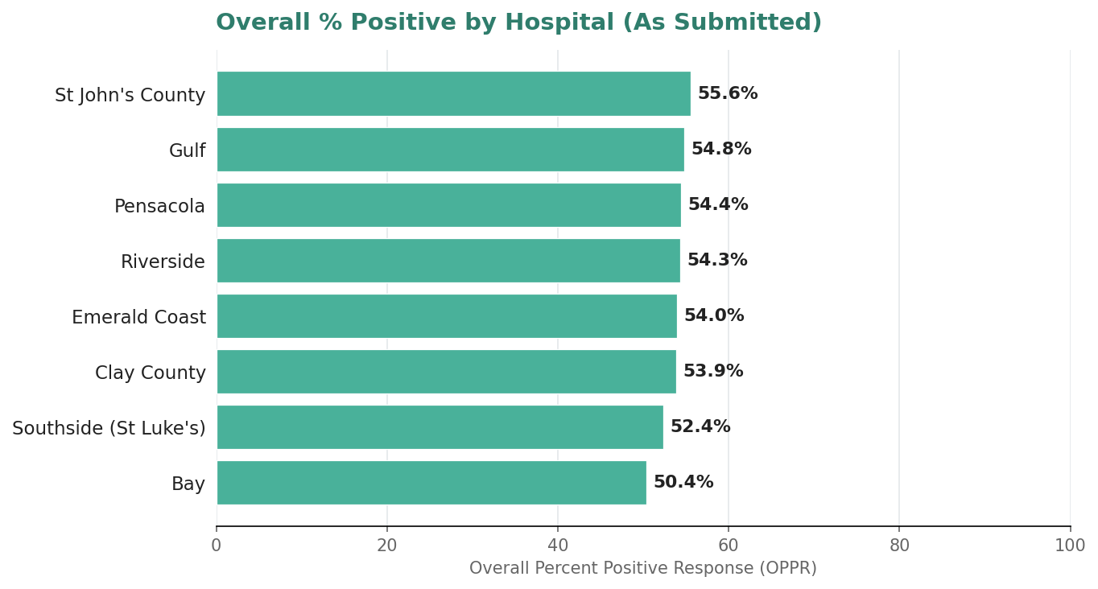
Figure 8: Overall % Positive by Hospital (As Submitted) shows unusually low OPPR (~50%) for each of the 8 hospitals
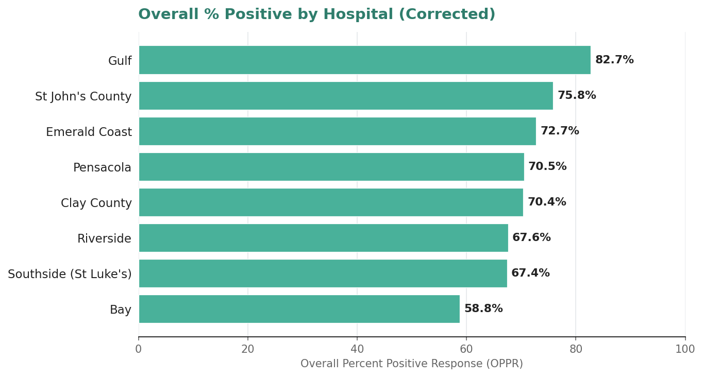 Figure 9: Overall % Positive by Hospital (Corrected) shows higher OPPR scores for each of the 8 hospitals
highlight
All facilities OPPR improve (min = +8.4%, max = +27.9%) due to the correction of the reverse-worded question coding
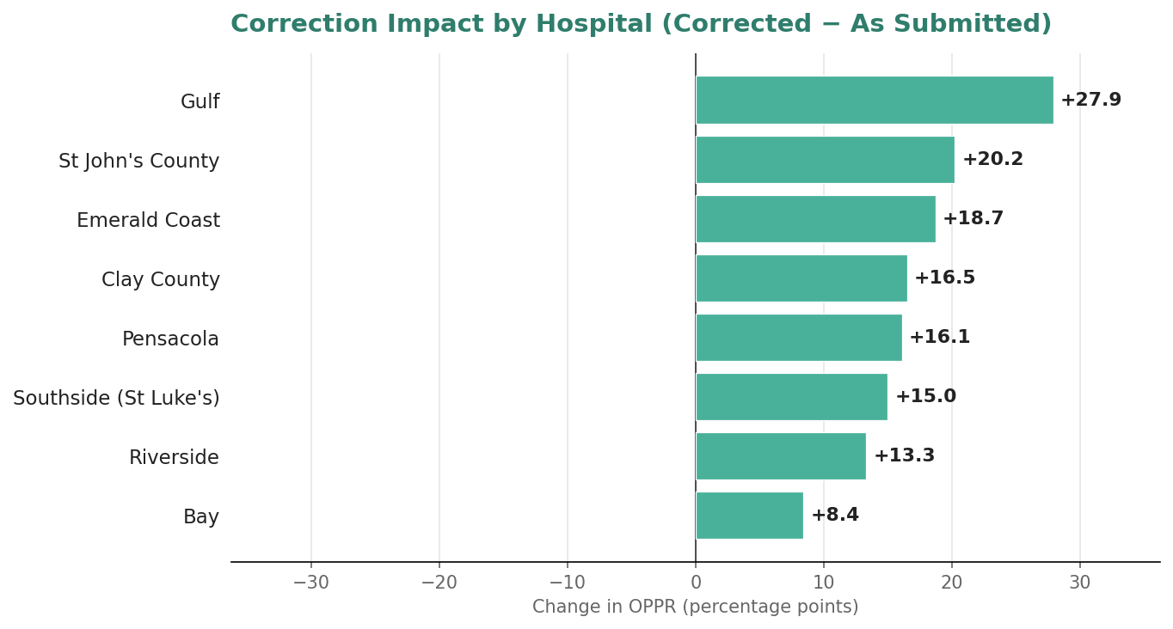
Figure 10: Correction Impact by Hospital (Corrected – As Submitted) shows improvement across all 8 hospitals

Section 7

Conclusion and Next Steps
The submitted figures understate patient safety culture at the affected composites because of a response-level inversion of thirteen negatively-worded questions introduced in the Prior Vendor export and not reversed by the AHCA data-entry tool. The corrected, validated results are ready for resubmission at the facility level.

Next steps
- AHCA resubmission: corrected facility files are validated and ready; target submission date [to be confirmed].
- Leadership communication: executive / CEO memo summarizing the issue and remediation; audience and timing [to be confirmed].
- Recurrence prevention: confirm the reverse-worded normalization convention with the vendor and in the AHCA tool workflow [to be confirmed].
- Owner and timeline: responsible party and key dates [to be confirmed].

https://beterra-presents-ahca.floridasafetyculture.com
https://beterra-presents-ahca.floridasafetyculture.com/compare “Distribution – All FL Hospitals”
https://beterra-presents-ahca.floridasafetyculture.com/compare “Composite Comparison Table”

